The Town of Swanzey has worked collaboratively with CAI Technologies to bring the town’s property tax maps online. The Geographical Information System, GIS, captures and displays data associated with a property’s geographical location. Some of the GIS layers include a base map, planimetric map, zoning map, prime wetlands and more!
To Use the GIS system:
Please click on the GIS link at the top of the Property Tax Maps & GIS page to get started.
Along the left side of the page you can search for information by the property address, owner’s name and PID (parcel ID). You can also turn the different map layers on and off.
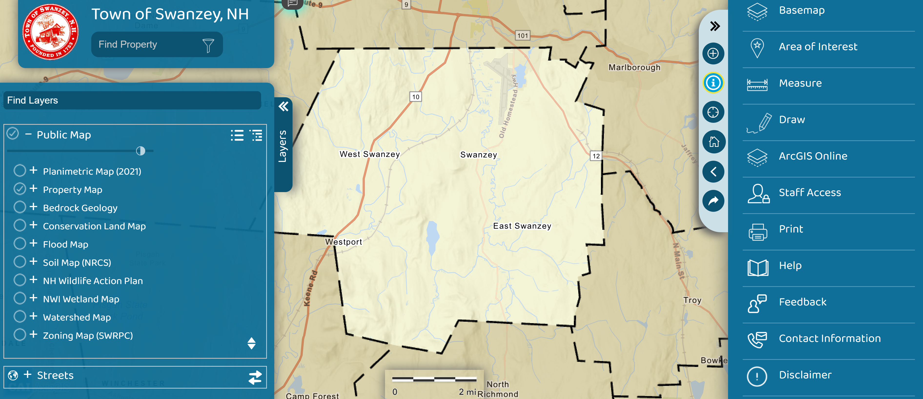
On the right side tool bar (revealed after clicking on the >>) there are additional tools and basemaps, including from the Town flyover data from 2021.
